***************************************************************************
Sixth Sunday After Pentecost
The Fruitful Life
July 27, 2025
Please listen in silence to the music of the Lord.

PRELUDE “The Power of thee Cross” Arr: Larry Shackley

WELCOME/JOYS AND CONCERNS

INTROIT Piano

CALL TO WORSHIP
L: The fruit of the Spirit is love, joy, peace, patience, kindness, goodness, faithfulness, gentleness and self-control. This is the fruit of a life joined to Christ.
C: We come desiring to grow in God’s Spirit and to live a fruitful life, for God’s glory and for our neighbor’s good. Let us worship God who makes us new.

INVOCATION

*OPENING HYMN “God is My Strong Salvation” #373

SCRIPTURE Philippians 4:4-9 The Peace of God
R: The Word of the Lord
C: Thanks be to God

CALL TO CONFESSION

CONFESSION (Unison)
God of peace, you promise a peace that guards our hearts and minds, but we confess how often we choose worry over trust, conflict over grace, and control over prayer. Forgive us. Settle our hearts in your presence and fill us with the peace of Christ. Amen.

WORDS OF ASSURANCE

INVITATION TO THE OFFERING

OFFERTORY Special Music: “There’s Something About That Name" William Gaither
Soloist Donald Nelson

*OFFERTORY PRAYER

HYMN “Dear Lord and Father of Mankind" #341

SCRIPTURE Isaiah 26:3

SERMON The Fruitful Life: PEACE Pastor Adam

PRAYER/LORD'S PRAYER
Our Father, who art in heaven, Hallowed be thy name.
Thy kingdom come. Thy will be done on earth, as it is
in heaven. Give us this day our daily bread. And
forgive us our sins, as we forgive those who sin
against us. And lead us not into temptation, but
deliver us from evil: For Thine is the kingdom, and the
power, and the glory, for ever. Amen.

*CLOSING HYMN "Savior, Again to Thy Dear Name" #60

BENEDICTION

POSTLUDE “Alleluia Sing to Jesus/All Hail King Jesus” Arr: Carol Tornquist

Pastor: Rev. Rick Miller
Guest Speaker: Pastor Adam Rohler
Organist and Choir Director: Ralph W. Farrar
Liturgist:
Ushers: Gary Carnes and Carolee Corbitt
Scripture Reader: Suzanne Campbell

Announcements

Worship Service at 10:00am

Thank you to everyone who worked on and came to the Hot Dog Roast Tuesday evening.

Next week’s loose offering goes to the Deaconry.

The United Church of Christ of Jamestown
70 McKinley Ave.
On Facebook at pilgrimfirstucc.
We extend a Jamestown, NY 14701
(716) 483-9665 Church Office
(716) 969-4826 Pastor’s Cell Phone
Our website is: www.pilgrimmeorialucc.org
Please join us warm welcome to our guests and visitors.

The People of the United Church of Christ in Jamestown
Welcome You

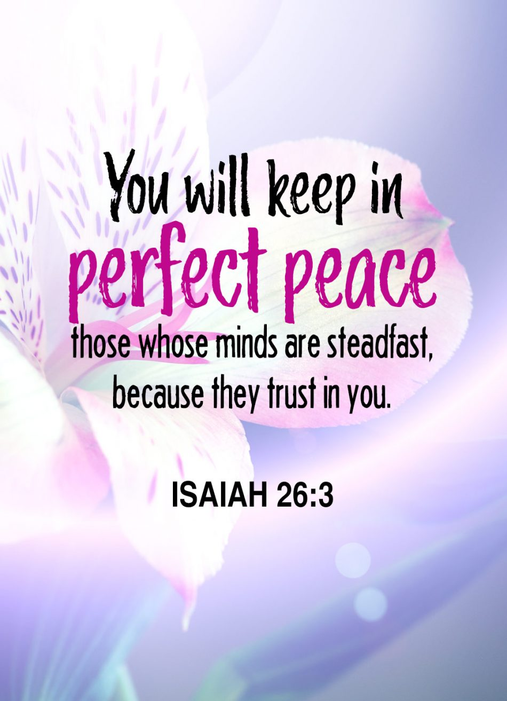

Ministers: Each one of us in the congregation made up of First Congregational Church and Pilgrim Memorial Church

