***************************************************************************
Fourth Sunday of Easter
May 11, 2025
********************************************************************

PRELUDE "Eternal Father, Strong to Save" Arr: Robert J. Hughes

WELCOME/JOYS AND CONCERNS

INTROIT

CALL TO WORSHIP (Psalm 23)
L: The Lord is our Shepherd; we shall not want.
C: He makes us lie down in green pastures; he leads us beside still waters.
L: He restores our souls and guides us in paths of righteousness.
C: Even though we walk through the darkest valley, we will fear no evil.
L: For you are with us – your rod and your staff they comfort us.
C: Surely your goodness and love will follow us all the days of our lives.
ALL: And we will dwell in the house of the Lord forever. Amen.

INVOCATION

*OPENING HYMN “Savoir, Like a Shepherd Lead Us" #327

SCRIPTURE READING
Revelation 7:9-17 A Multitude Sings Before the Lamb
R: The Word of the Lord
C: Thanks be to God

CALL TO CONFESSION

CONFESSION
Forgive us gracious God, for what we have done to bring pain to your beautiful world: our hard and unkind words, our careless and thoughtless deeds, our lack of compassion and reluctance to render aid when it was in our power to help. Amen.

WORDS OF ASSURANCE

ANTHEM "Let Them Come" Valerie Mackenzie

INVITATION TO THE OFFERING
OFFERTORY "Holy Spirit, Truth Divine" Arr: Lani Smith
DOXOLOGY Praise God from whom all blessings flow: Praise him all creatures here below; Praise him above, ye heavenly host: Praise Father, Son, and Holy Ghost. Amen.
*OFFERTORY PRAYER
HYMN "The King of Love My Shepherd Is" #80
SCRIPTURE John 10:22-30
SERMON "Jesus Promises Life and More Life" Pastor Rick
PRAYER/LORD'S PRAYER
Our Father, who art in heaven, Hallowed be thy name.
Thy kingdom come. Thy will be done on earth, as it is
in heaven. Give us this day our daily bread. And
forgive us our sins, as we forgive those who sin
against us. And lead us not into temptation, but
deliver us from evil: For Thine is the kingdom, and the
power, and the glory, for ever. Amen.

*CLOSING HYMN “All Hail the Power of Jesus’ Name" #195

BENEDICTION

POSTLUDE “Firm in the Faith I Stand" David Paxton

Pastor: Rev. Rick Miller
Organist and Choir Director: Ralph W. Farrar
Liturgist: Jerry Steves
Ushers: Gary Carnes and Carolee Corbitt
Scripture Reader: Wendy Wilcox

Announcements

Worship Service at 10:45am
Bible Study Thursdays at 1:00pm
Choir Practice at 7:00pm

Happy Mother’s Day!

Deacons & Trustees meet after church.

If you would like to send Diane Nelson a card, her room number at UPMC/WCA, 207 Foote Avenue is 441

**May 18: Board Meeting and cake for Georgia Hiller’s 99th Birthday!

The United Church of Christ of Jamestown
70 McKinley Ave.
On Facebook at pilgrimfirstucc.
We extend a Jamestown, NY 14701
(716) 483-9665 Church Office
(716) 969-4826 Pastor’s Cell Phone
Our website is: www.pilgrimmemorialucc.com
Please join us warm welcome to our guests and visitors.

The People of the United Church of Christ in Jamestown
Welcome You

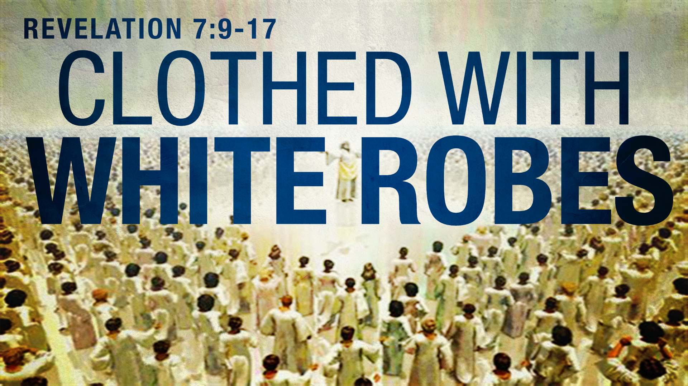

Ministers: Each one of us in the congregation made up of First Congregational Church and Pilgrim Memorial Church

