***************************************************************************
Second Sunday After Pentecost
June 22, 2025
Please listen in silence to the music of the Lord.
PRELUDE "Nobody Knows the Trouble I've Seen" Clarence Kohlman
WELCOME / JOYS AND CONCERNS
INTROIT Choral Response

CALL TO WORSHIP
L: Come, let us seek God together.
C: Our hearts long for him like water for the thirsty.
L: When we feel down or far from God –
C: We will remember his love and put our hope in him.
L: God sends his light to guide us.
C: He brings us back with joy and peace.
All: We will worship God, our hope and our help – now and always!

*INVOCATION

*OPENING HYMN “Immortal, Invisible, God Only Wise” #7

SCRIPTURE Psalm 42:1-11, 43:1-5
R: The Word of the Lord
C: Thanks be to God

CALL TO CONFESSION

CONFESSION
Merciful God, we confess that we have wandered from you. We have let fear and worry cloud our trust, and we have not always loved others as you call us to. Forgive us, renew us, and lead us into a deeper walk with you. Restore our hope and joy. Amen.

WORDS OF ASSURANCE

CHORAL ANTHEM “Create In Me a Clean Heart, O God” Carl Mueller

INVITATION TO THE OFFERING

OFFERTORY “Sweet Hour of Prayer" W. B. Bradbury

*DOXOLOGY Praise God from whom all blessings flow: Praise him all creatures here below; Praise him above, ye heavenly host: Praise Father, Son, and Holy Ghost. Amen.

*OFFERTORY PRAYER
HYMN “Immortal Love, Forever Full" #230
SCRIPTURE Galatians 3:23-29 and Luke 8:26-39
SERMON “Clothed in Christ: Our True Identity” Doug Hearn

PRAYER / LORD’S PRAYER Our Father, who art in heaven, Hallowed be thy name. Thy kingdom come. Thy will be done on earth, as it is in heaven. Give us this day our daily bread. And forgive us our sins, as we forgive those who sin against us. And lead us not into temptation, but deliver us from evil: For Thine is the kingdom, and the power, and the glory, for ever. Amen.

*CLOSING HYMN "O For a Closer Walk With God" #350

BENEDICTION

POSTLUDE “Festival Postlude” Domenica Zipoli

Pastor: Rev. Rick Miller
Guest Speaker Douglas Hearn
Organist and Choir Director: Ralph W. Farrar
Ushers: Gary Carnes and Carolee Corbitt
Scripture Reader: Gary Loll
Liturgist: Pastor Rick

Announcements

Worship Service at 10:45am
Choir Practice at 7:00pm

Thank you Doug for leading us today and next Sunday.

Board Meeting and Coffee Hour today.

Lunch will be provided after church before the prayer walk next Sunday. Please sign up to take part in this outreach. We need everyone’s participation. If you cannot walk you can take part inside the church.

The United Church of Christ of Jamestown
Please join us at:
70 McKinley Ave.
Jamestown, NY 14701
On Facebook at pilgrimfirstucc.
(716) 483-9665 Church Office
(716) 969-4826 Pastor’s Cell Phone
Our website is: www.pilgrimmemorial.com
We extend a warm welcome to our guests and visitors.

The People of the United Church of Christ in Jamestown Welcome You

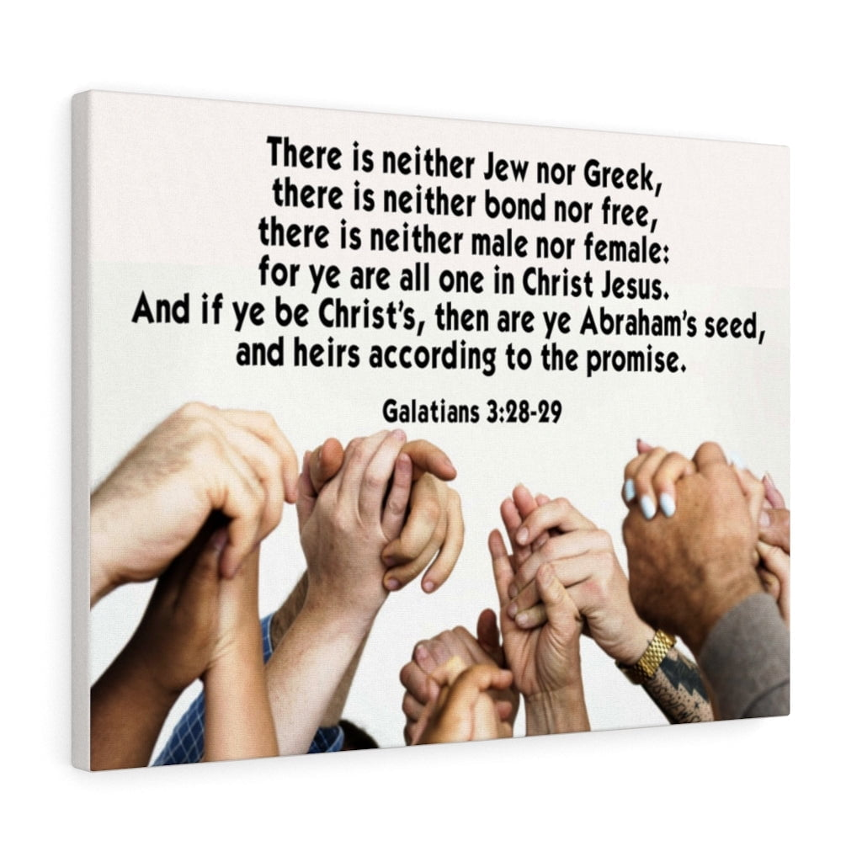

Ministers: Each one of us in the congregation made up of First Congregational Church and Pilgrim Memorial Church

